
Dhaka International University
Lab Report details:
Lab Report Topic : Java Multithreading Through Thread and Runnable Interfaces
Lab Report No :11
Course Title : Object-Oriented Programming Languages
Course Code : 0613-202

Submitted By: | Submitted To:
S M Nabil Ausaf  Roll: 01  Reg No : CS-D-91-23-124492 | Prof. Md. Abdul Based

Date of Submission: 11 Nov 2024

Objective:
To implement multithreading in Java using both the Thread class and Runnable interface, and demonstrate simultaneous execution of multiple threads.

Components Used:
- Java Development Kit (JDK)
- Integrated Development Environment (IDE) such as IntelliJ IDEA, Eclipse, or NetBeans
- Computer System with Java installed

Theory:
Multithreading is an essential concept in Java that enables the execution of multiple threads simultaneously, resulting in enhanced performance and efficiency. There are two major ways Java achieves threads:
1. Extending the Thread class and overriding the run method.
2. Implementing the Runnable interface and overriding the run method.

A single thread may be initiated by invoking the start () method, which calls the run () method. The Thread.sleep(time) method is called to suspend a thread for a certain period of time.
Two threads are initiated in this test:
- Thread1 extends the Thread class and CSE is printed five times with a gap of 10 seconds between prints.
- Thread2 implements Runnable and DIU is printed five times with a gap of 1 second between prints.
- A third class, Thread3, creates and starts both threads to show concurrent execution.

Code Implementation
- Thread1:
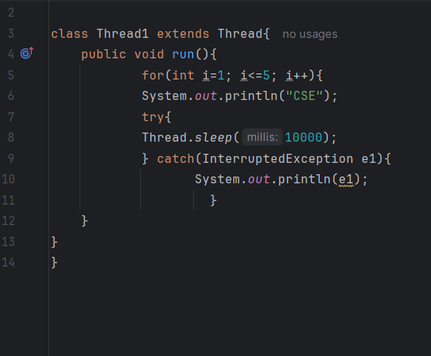

- Thread2:
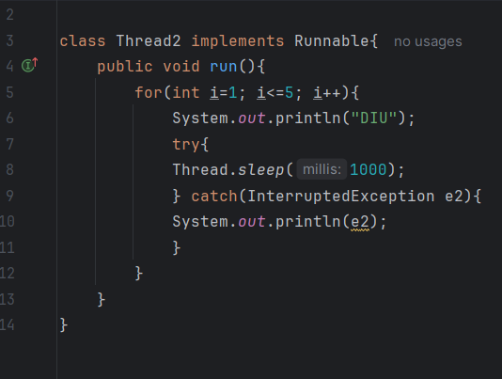
Thread3:
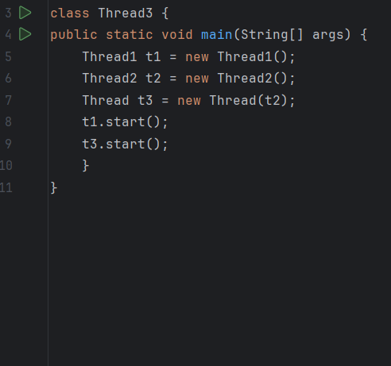
Design Procedure:
1. Define a class Thread1 extending `Thread` and overriding the run() method to print "CSE” five times with a delay.
2. Define a class Thread2 implementing Runnable and overriding the run() method to print "DIU" five times with a delay.
3. In Thread3, create Thread1 and Thread2.
4. Cast Thread2 to a Thread object and call the start() method for both threads.
5. Observe the concurrent execution of the threads.

Expected Output (Concurrent Execution)
Example Output:
,,,
DIU
DIU
DIU
DIU
DIU
CSE
CSE
CSE
CSE
CSE
```
(Note: The order may vary due to concurrent execution of threads.)

Discussion:
- Thread1 is a class extending Thread and runs independently.
- Thread2 is a class implementing Runnable, which demonstrates another approach to multithreading.
- Thread.sleep() method is utilized to pause execution, causing delays.
- The order of output is not fixed since thread scheduling is handled by the JVM.
- The experiment illustrates the strength of multithreading when dealing with concurrent tasks.

Conclusion:
This lab experiment distinctly exhibits Java's multithreading feature through Thread and Runnable. Through concurrent execution of more than one thread, we attain effective execution of tasks with a decrease in the execution time of the program. This is a vital concept in creating programs needing parallel processing, including real-time systems and high-performance applications.

